Fact sheet

PowerAllocatorTM

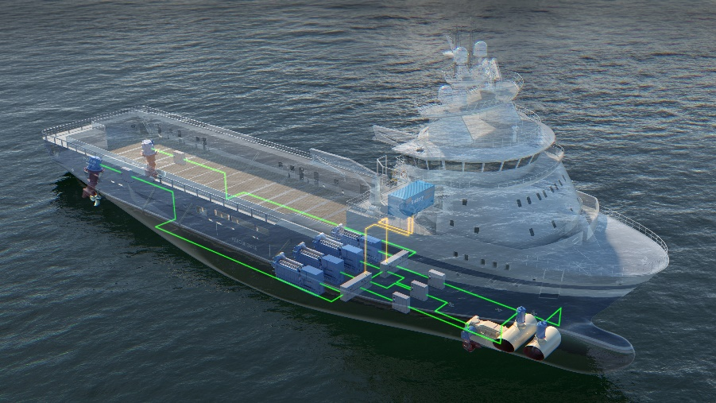

The demand for green solutions in the maritime industry is
driving an increased use of clean electrical power systems
that utilize flexible energy sources. Kongsberg Maritime
PowerAllocatorTM is an energy solution for conventional power
systems as well as complex systems.
It is integrated with our cutting-edge DP system to achieve

KONGSBEGRS MARITIME

ENERGY SOLUTIONS PROPELLING THE SHIPPING INDUSTRY TOWARDS GREATER SUSTAINABILITY
unique additional energy savings

PowerAllocatorTM

About
Our mission is to help our customers lower the lifetime cost and emissions while maximising their investment in power systems. The PowerAllocator™ is a novel, patent pending Energy Storage Solution that will supply and optimally allocate power between redundancy groups from a single, autonomous battery system.
Our PowerAllocatorTM offers significant fuel efficiency gains, reduced emissions at reduced cost, space, weight and complexity compared to conventional energy storage solutions.

The PowerAllocator™ constitute a new redundancy group that is autonomous from all main redundancy groups with regards to failures and propagation under IMO equipment DP class 2 (DP2) and 3 (DP3).

The PowerAllocatorTM allows the engines to run at increased fuel efficiency and enables full flexibility in power system setups. The energy storage is available for spinning reserve and power peak load smoothing for all main redundancy groups in both open and closed bus operation.

The PowerAllocator™ allows for less installed battery capacity reducing the CAPEX when compared with conventional setups where an energy storage system is installed in each redundancy group.



SAVINGS
Reduced Maintenance

The Main Advantages of PowerAllocatorTM
Compared to traditional energy storage installation, the PowerAllocatorTM has several advantages:

• The PowerAllocator™ allows monitoring and allocation of power between redundancy groups even if bus-ties between main redundancy groups are open. Hence, proving benefits similar to operating with closed bus-ties between all redundancy groups, thus minimizing operational restrictions and increasing operational safety.
• The PowerAllocator ™ always stays connected. No operator intervention is required when changing switchboard and/or engine configuration.
No battery capacity is lost in case of failure of any of the main redundancy groups with engines due to the fault tolerant design.

The PowerAllocator™ will:
• Reduce installed battery capacity and only require a single battery room
• Reduce CAPEX, space & weight
• Improve DP capability and reduce OPEX and emissions in open bus operation

Comparing figure 1 with figure 2 and 3 it is shown that the number of ESS`s can be reduces from three to one.

Figure 1 Convectional installation with one ESS on each main bus segment
Figure 2 PowerAllocatorTM principal with one combined ESS feeding all bus segment

Figure 3 PowerAllocatorTM principal with one combined ESs feeding all bus segment
In cases where the power system does not have failure ride through, the PowerAllocatorTM can allocate power between segments as shown in figure 4. This ensures “open bus” operation with “closed bus” benefits such as increased fuel efficiency and full flexibility in power system setups.

Figure 4 PowerAllocatorTM allocating power between bus segments

Spinning Reserve



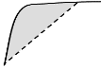

Performance Boost
Peak Shaving
Energy Storage
In a PowerAllocatorTM the energy storage is designed and implemented to increase peak loading capabilities on energy producers and avoid running of redundant energy producers.

Energy Storage main benefits:

• Limits load fluctuations which stabilizes the load of the power producer. (Peak Shaving)
• Provide instantly available power to compensate for sudden load steps. (Power Boost)
• Allows dynamic performance beyond ability of power producers (Performance Boost)
• Power plant utilization optimized for each operational mode and variable power required. (Flexible power production)
•Minimize redundancy running of power producers. (Spinning Reserve)
•Reduced environmental footprint through significant direct and indirect reductions of emissions
•Optimized power plant designs reducing overall cost of vessel construction (CAPEX)
•Enable optimized operation of the power plant, reducing running hours and maintenance as well as fuel and emissions (OPEX)
•Reduced engine stress, soothing, running hours, and extended maintenance intervals
Flexible Power Production
Proper protection
Propper protection of the PowerAllocatorTM solution is achieved by a combination of conventional protection methods and unique power component devices. Since protection devices has a controllable switching the fault current can be blocked much faster than what is possible with traditional circuit breakers with associated protection relay. This gives the possibility for safe operation with a combined DC link in the PowerAllocatorTM. Additional protective devices covering the hidden failure aspect is also used in the different setups.
Figure 5 shows some a failure mode in a main redundancy group

Figure 5 Failure Mode
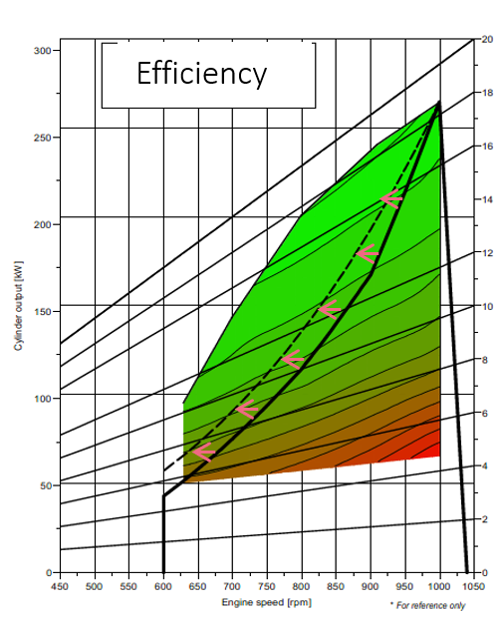
Figure 6 Efficiency Curve with energy control
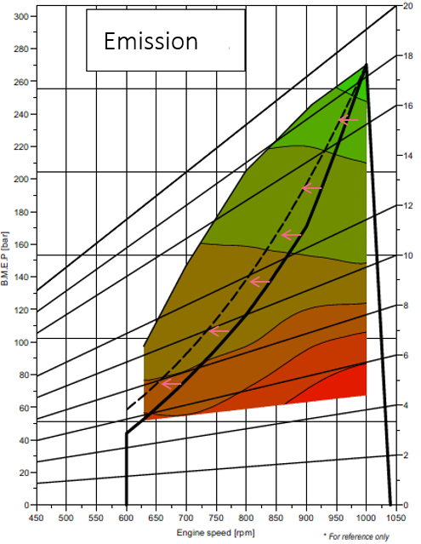
Figure 7 Emission Curve with Energy Control

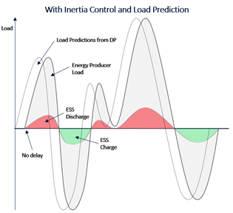
Figure 8 Energy Storage curve with Energy Control

Energy Control

Kongsberg Maritime offers a solution that includes an energy control system to control the power flow and power sharing between power producers and energy storage. Our unique and patented energy control system for the PowerAllocatorTM extracts and shares information between all components in the digital power layer. Tight synchronized DP integration with load prediction delivers unique features.

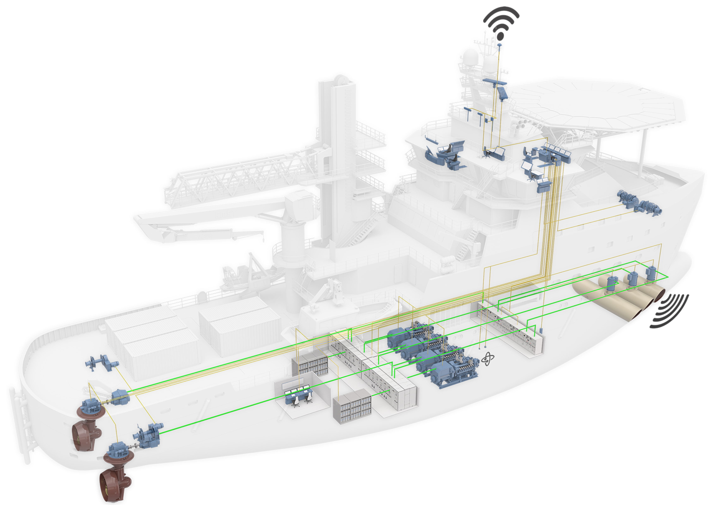

Core components of the novel Energy control includes load prediction and inertia control combined with conventional power management system functionality. Predictions of future thruster demand controls the energy production and energy storage charge / discharge. Load dynamics shared between the energy storage and producers ensures optimization for both producer limitations and energy storage lifetime.

The Energy Control uses the PowerAllocatorTM unique features to allocate power where it achieves most benefits even when busties between the main redundancy group are open. The interaction between the cutting-edge DP technology and the Energy Control makes its possible to provide power to thrusters and bus segments that will provide the most efficent use of the power to maintain the DP position. This also applies after WCFS where a energy producer or producer segment is lost. Then the Energy Control will instruct the PowerAllocatorTM to provide power to the remaining segments and thrusters that will ensure the best position keeping capabilities

Another unique Energy Control function is “PowerBoost™”. This function allows for increased dynamic performance. When a vessel shifts position in DP operation, also known as “in field transit” or “repositioning” there can be a time window of power demand beyond the ability of the online energy producers.
Due to energy control DP integration, the ESS can be used for “power boosting” covering the temporally gap between available power and required power. The close interaction between Energy Control and DP secures positioning after WCFS in addition to having temporarily additional dynamic performance. This is possible due to our cutting-edge DP systems ability to differentiate power demand requirements in different stages of the DP operation and predict future load and energy requirement.
The advantage of this compared to a conventional power management system is avoiding standby start of energy producers. Witch again gives reduced fuel consumption and reduced maintenance cost.


Energy Control main functions:
• Limits load fluctuations in order to stabilize the load of the producers (increases available power for propulsion and other processes)
• Load predictions used for improved handling of the load dynamics
• For DP vessels with required redundancy design:
• Minimum SOC is set based on the calculated DP requirement for the operation in case of worst single failure
• Looking at the total available inertia on the power plant in all different modes of operation. The DP will distribute the available inertia to all thrusters, matching the load ramps within the producers capability
• Energy Control ensures green operations by configuring zero emission modes with use of ESS and alternatively shore power
“Full Picture” additional benefits
Our “Full Picture” benefits ensure operating energy producers in the most optimal way by reducing speed and shifting operational load limits with use of load prediction and energy control.
• Our Energy Storage implementation enables reduction of energy producers, hence increasing efficiency on remaining producers. In addition, our Energy Storage is only utilized when ramp and load demand is outside the producers capability or an energy producer is unexpectedly disconnected.
• Our Inertia Control with Dynamic Positioning System Integration, enable shift of load limit on energy producers by utilizing load prediction that will increase efficiency and reduce emission as shown in figure 6 and 7.
• With our “full picture” integration and load prediction, the energy producer speed can be increased before the load is applied, avoiding energy storage discharge as shown in figure 8, hence decreasing energy storage size requirement and increasing life due to less usage.
Proven Power Allocator Solutions
Kongsberg Maritime has several PowerAllocatorTM solutions in operation in the offshore segment. Below example on the vessels Normand Falnes and Normand Naley upgraded in 2019

